**VPC CREATTION:**

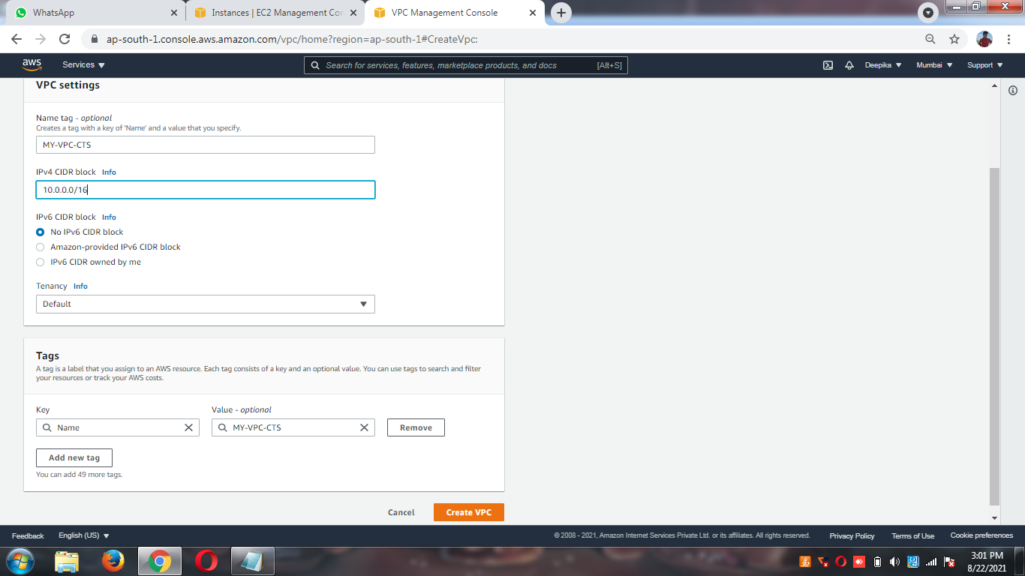

**HDFC_PUBLIC SUBNET CREATION**

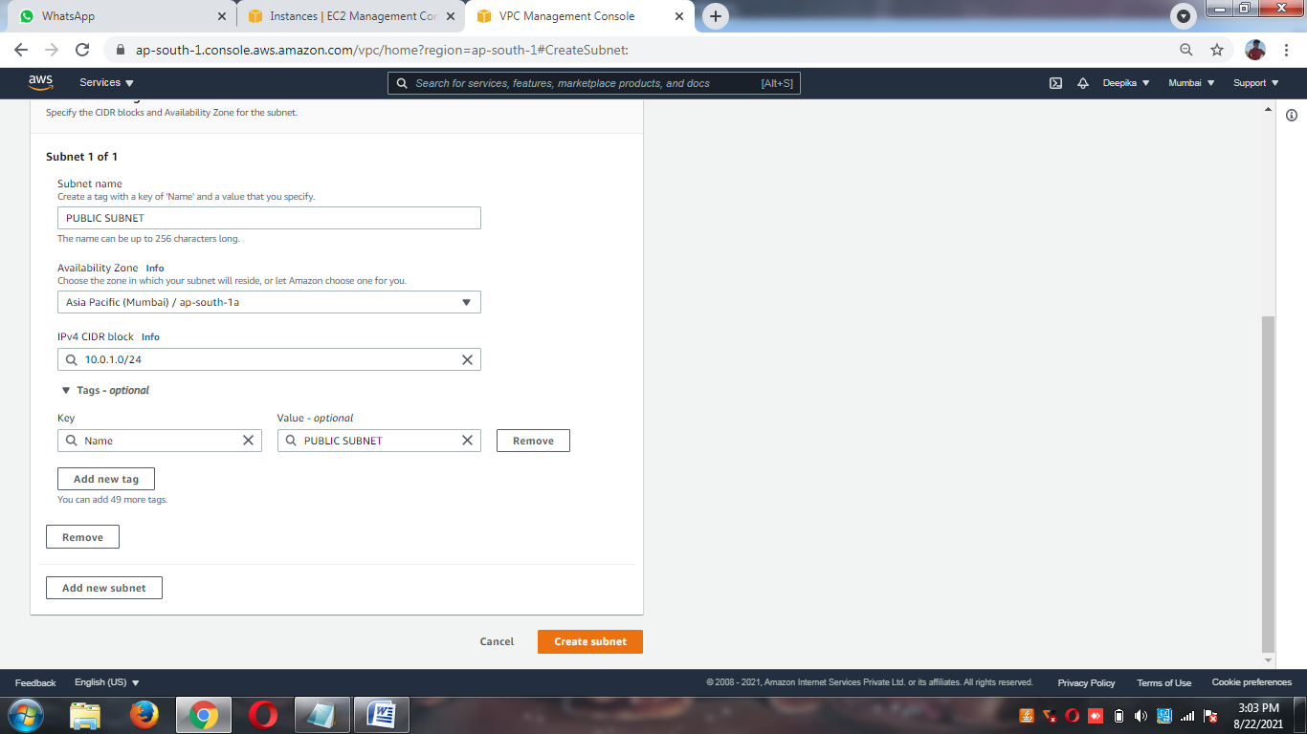

**HDFC_PRIVATE SUBNET CREATION**

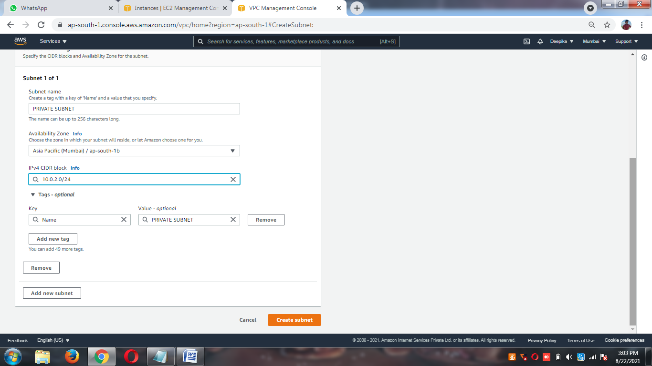

**INTERNET GATEWAY CREATION**

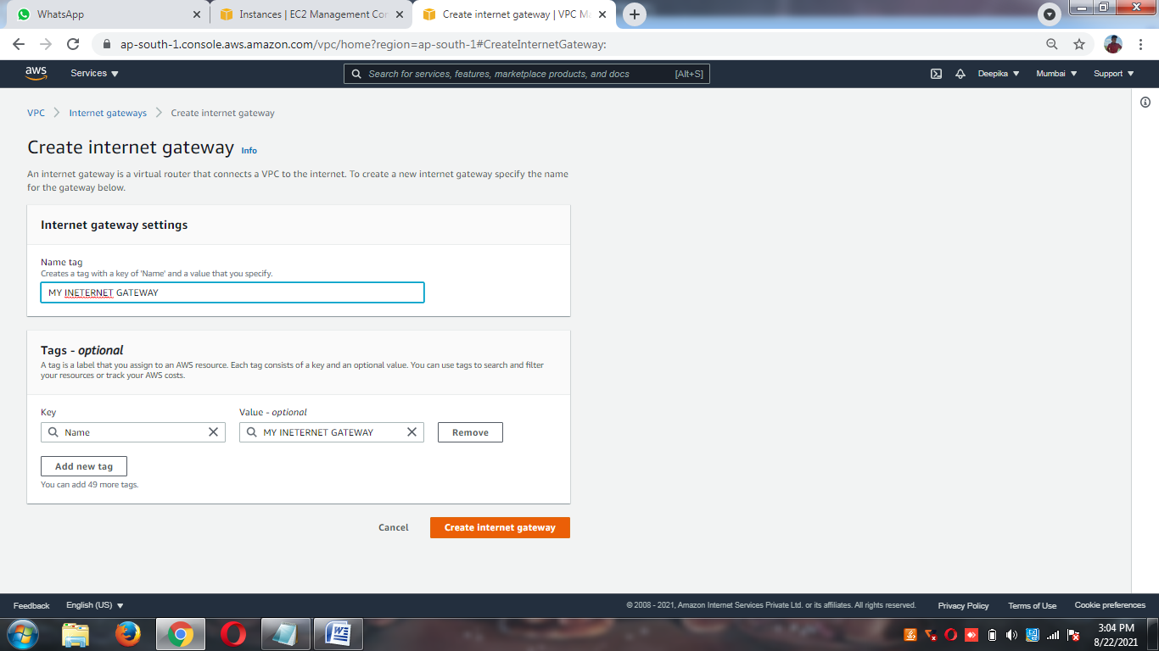

**INTERNET GATEWAY ATTACHMENT TO CTS VPC**

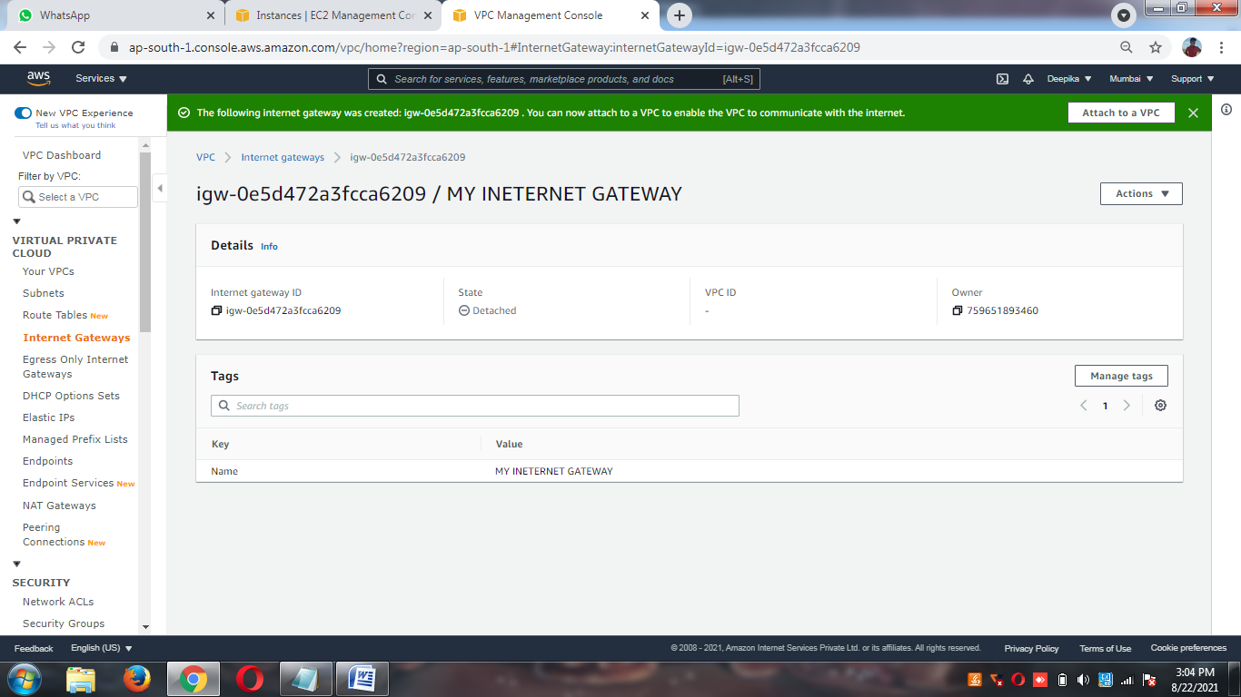

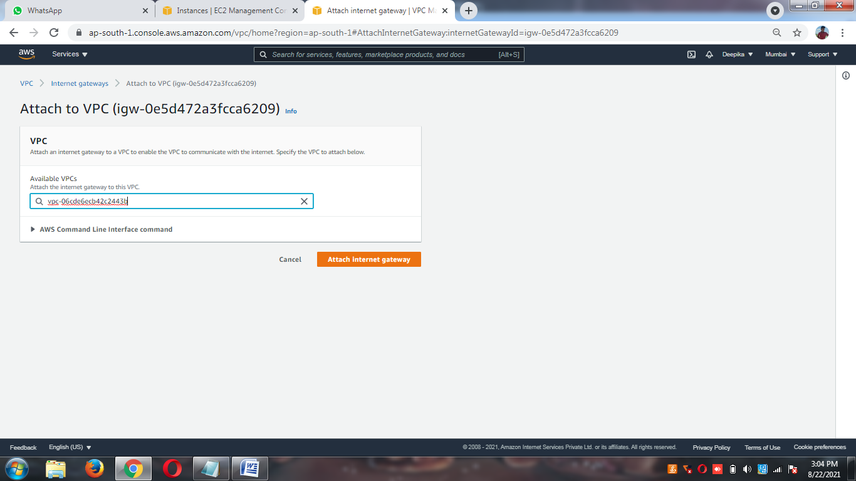

**PUBLIC ROUTE TABLE CREATION**

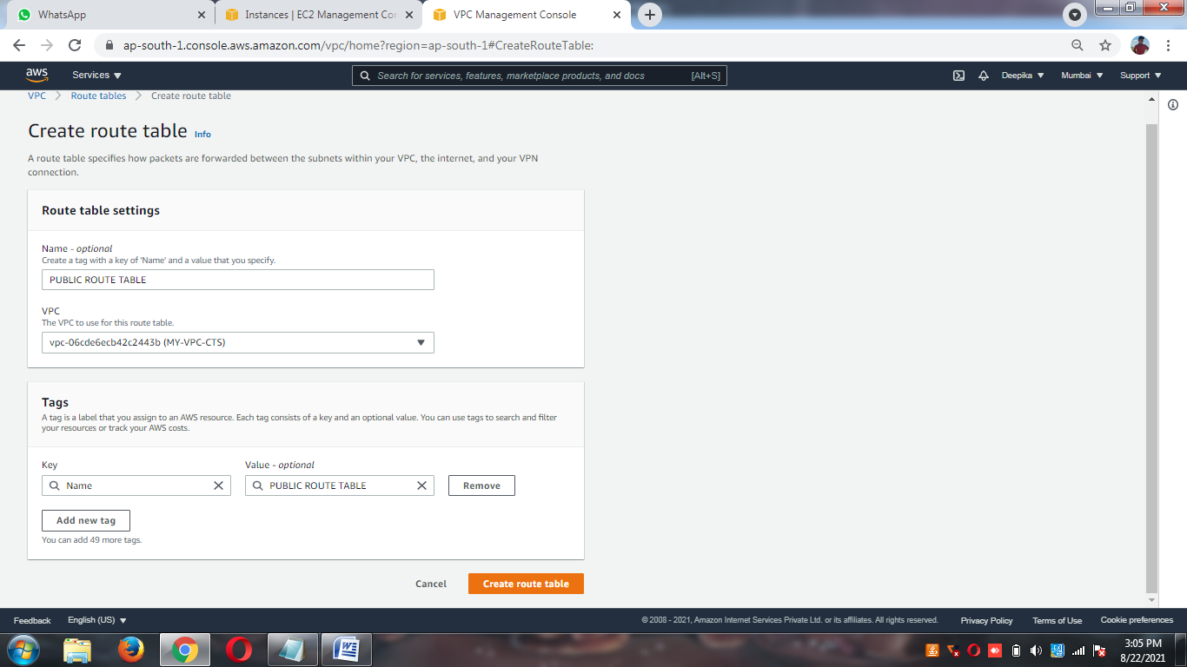

**PRIVATE ROUTE TABLE CREATIONS**

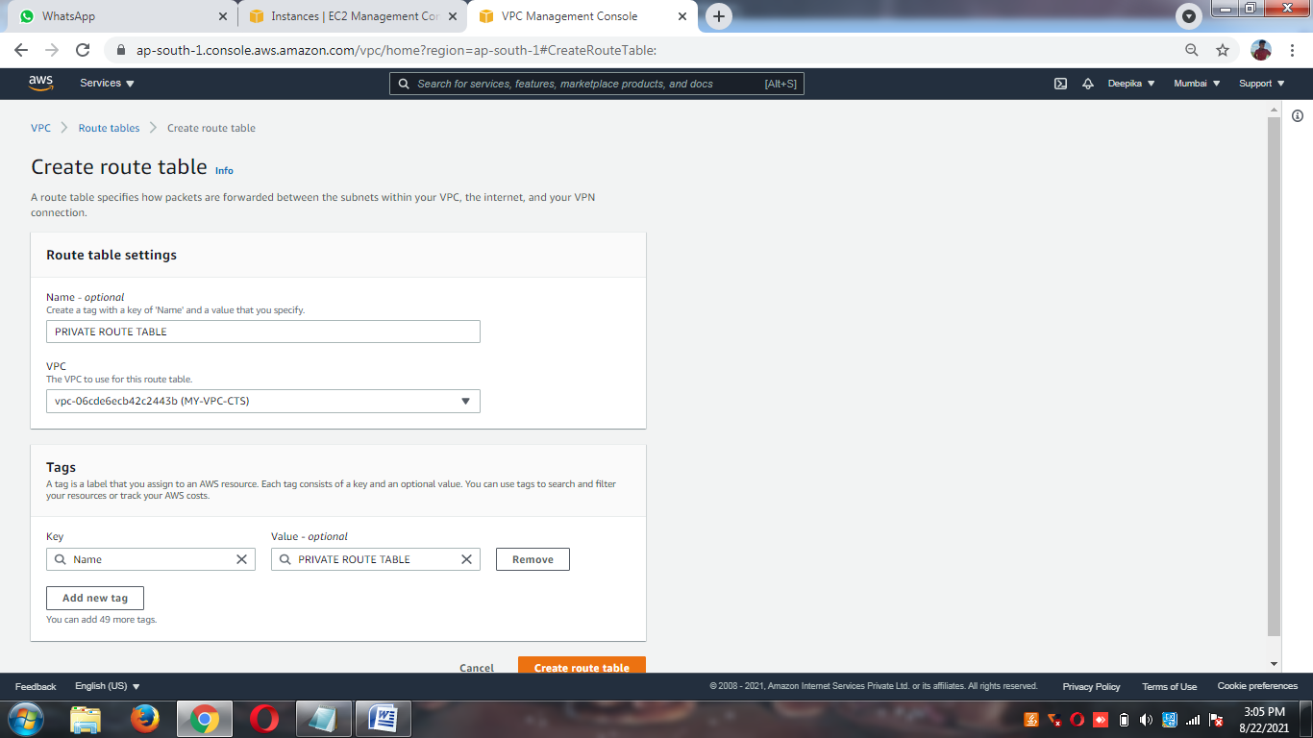

**PUBLIC ROUTE TABLE TO PUBLIC SUBNET ASSOCIATIONS**

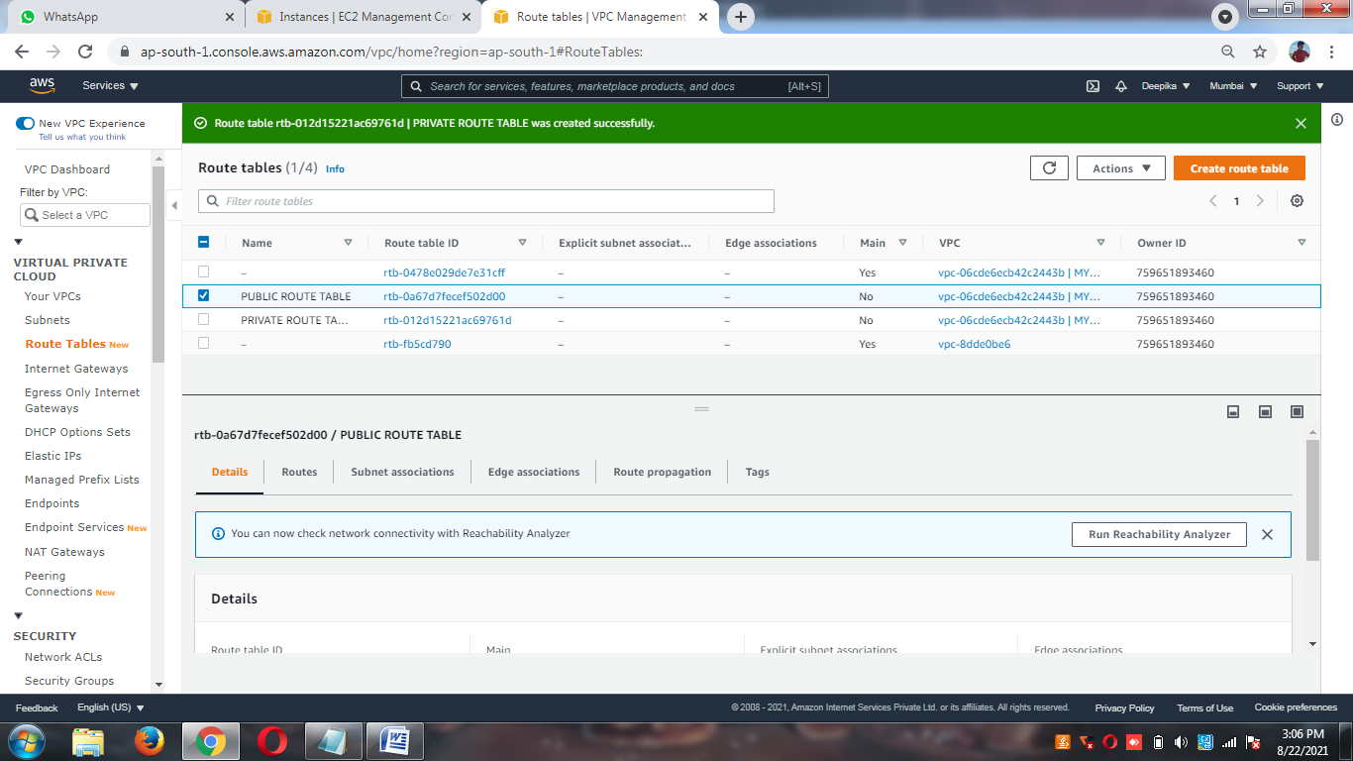

**PRIVATE ROUTE TABLE WITH PRIVATE SUBNET ASSOCIATIONS**

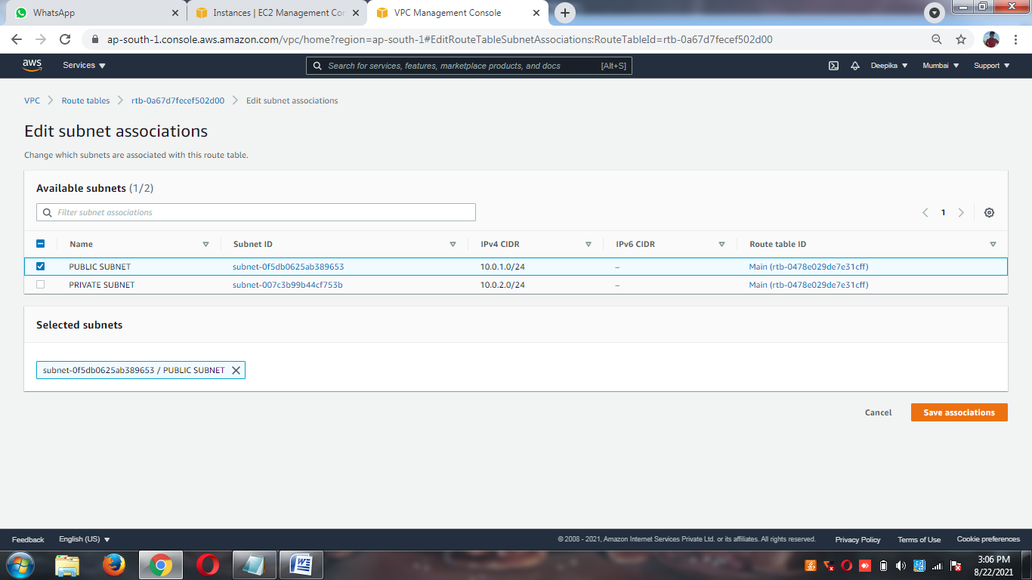

**ROUTES INTERNET FROM IGW TO RT**

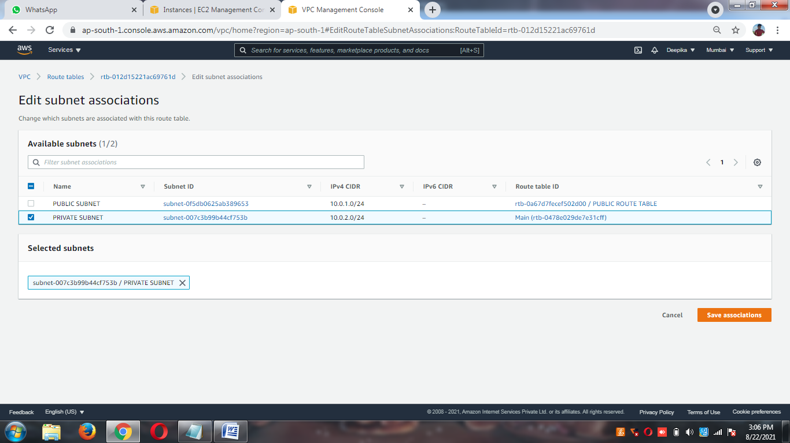

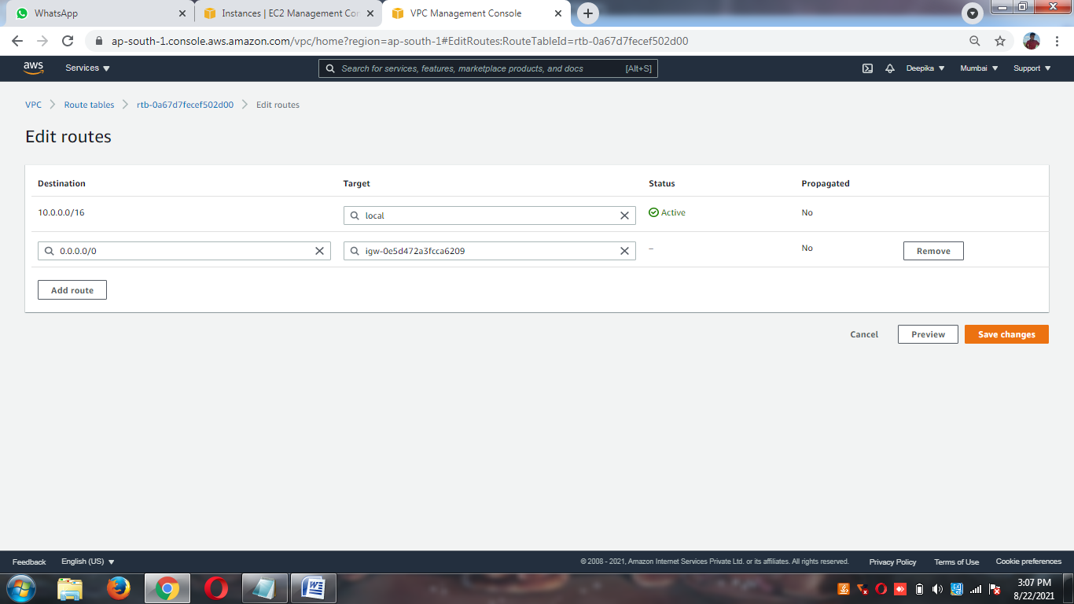

**PUBLIC SECURITY GROUP CREATION**

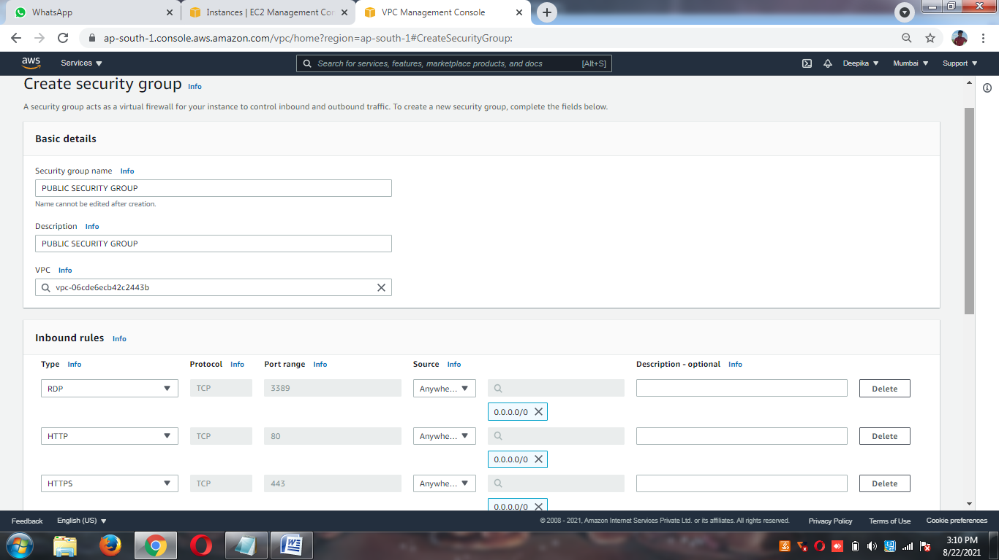

**PRIVATE SECURITY GROUP CREATIONS**

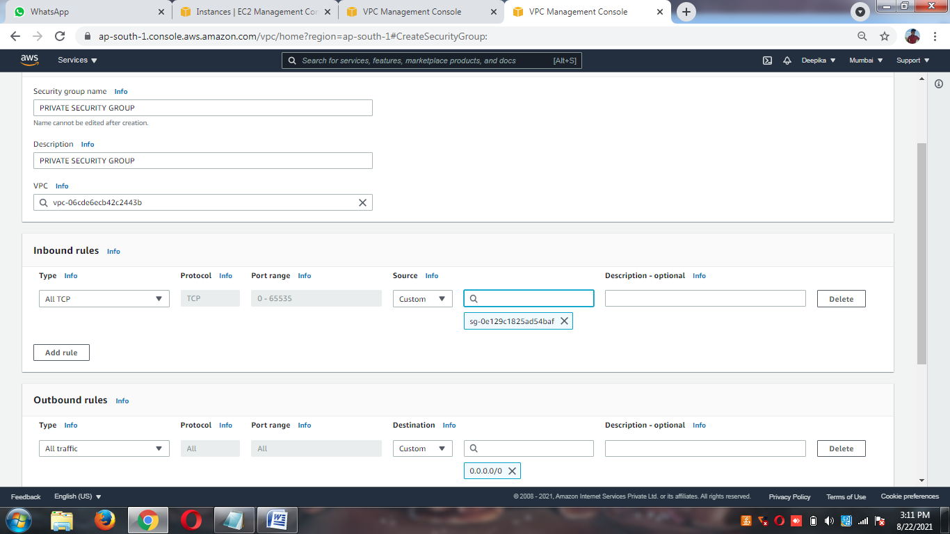

**WEBSERVER CREATIONS**

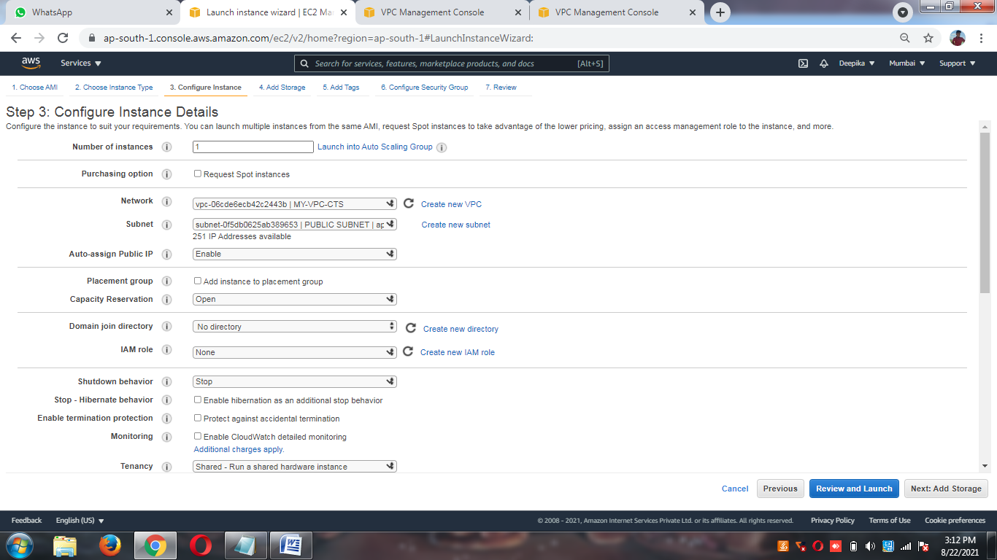

**APPSERVER CREATIONS**

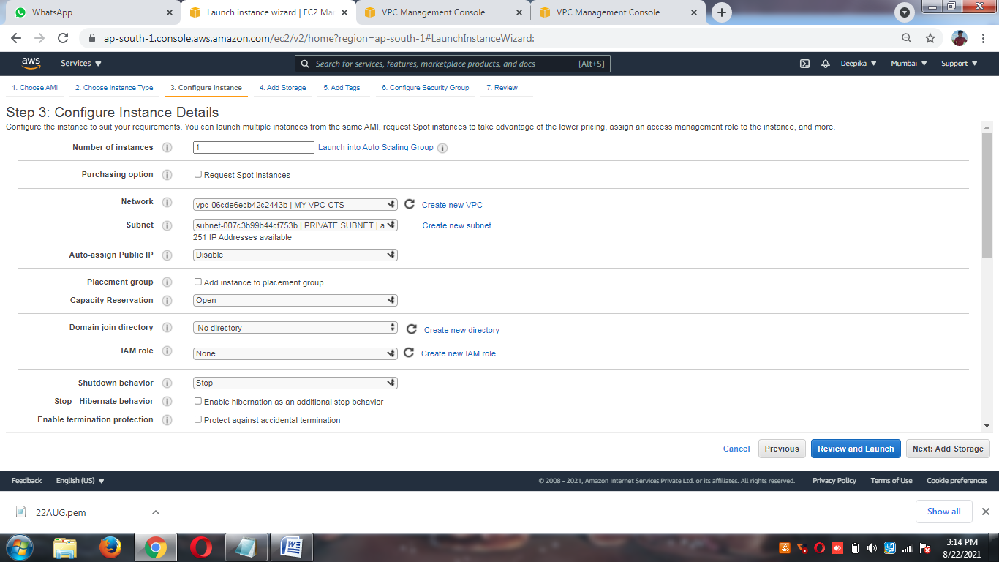

**NAT GATEWAY CREATIONS**

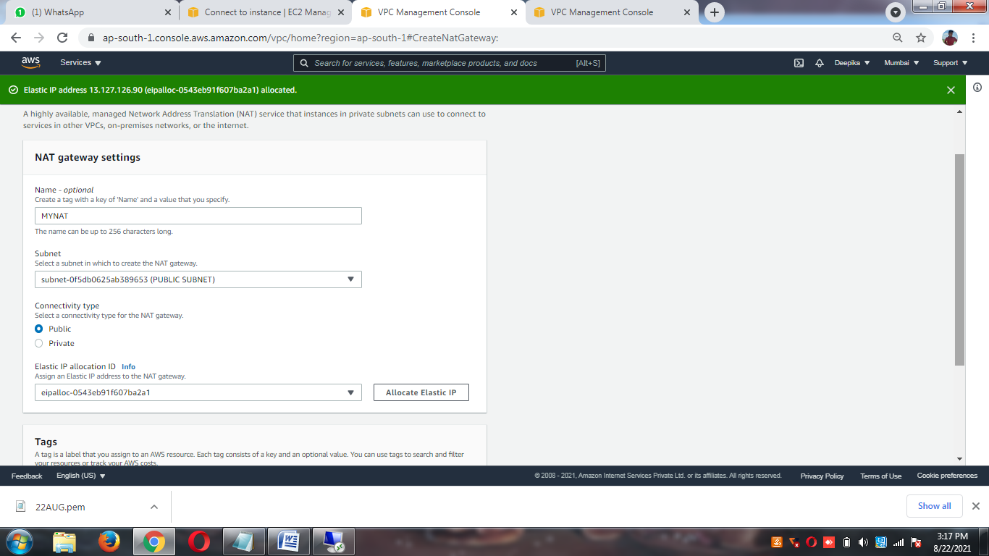

**CHECK INTERNET OF THE APPSERVER**

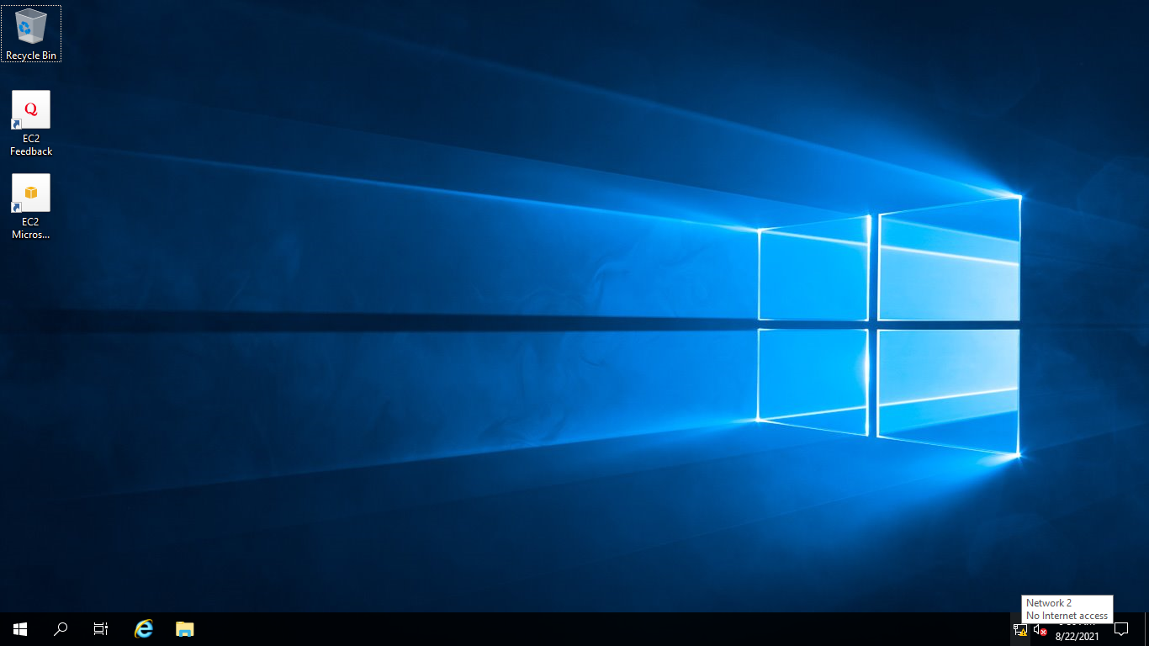

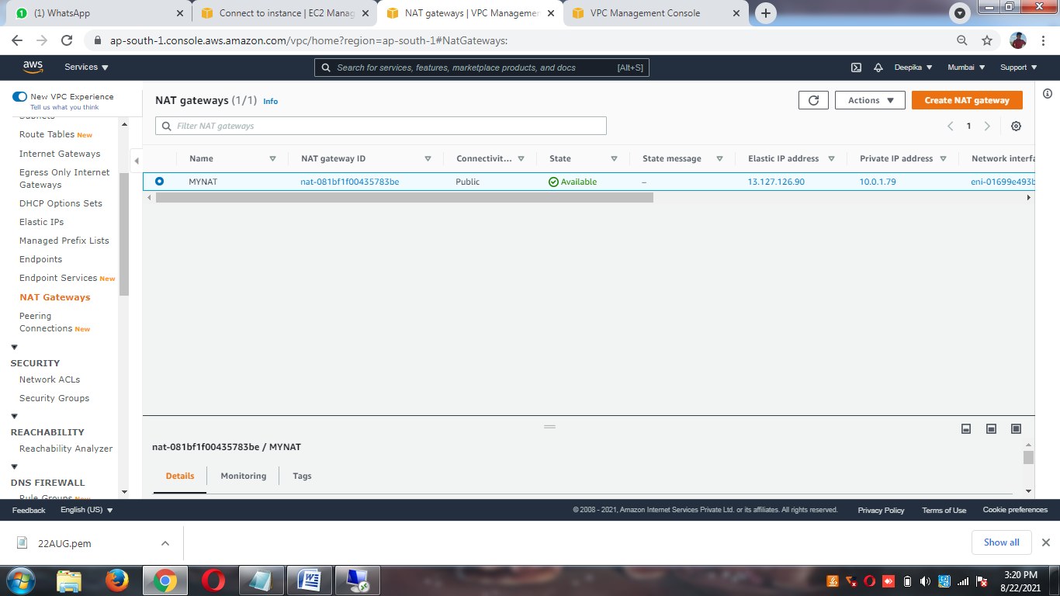

**ROUTE THE INTRANET FROM PUBLIC SUBNET TO PRIVATE SUBNET**

**ROUTES FROM NAT TO PRIVATE RT**

**NOW, CHECK THE INTERNET IN THE APPSERVER**

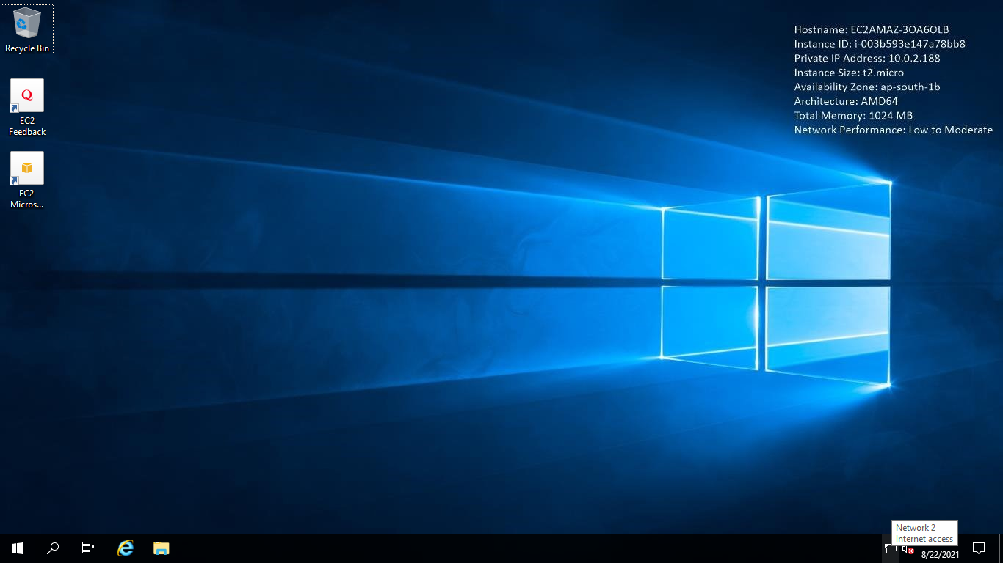

**Demolish: nat,elastic ip, instances, vpc**